Student name: Ali Alnazzal

Course: COMM 5240 Organizational communication

Instructor: Prof. Tmara Powel

Organizational Communication and Policy Change: CU Denver Student Attitudes Toward the Elimination of DEI Programs

University of Colorado Denver

Abstract
This study investigates the organizational communication challenges triggered by the 2025 Executive Order (EO) eliminating Diversity, Equity, and Inclusion (DEI) programs in American higher education, with a focus on the University of Colorado Denver (CU Denver). The EO, implemented through top-down directives and reinforced by Department of Education guidance, compelled universities to rapidly dismantle or rebrand DEI initiatives, often with minimal stakeholder input or transparent dialogue. This abrupt policy shift exposed significant organizational communication conflict, including a lack of collaborative decision-making, increased uncertainty and anxiety among students and staff, and inconsistencies in institutional messaging. Drawing on historical context, legal developments, and mixed methods of online observation and original survey data, the study reveals that CU Denver’s swift compliance-characterized by surface-level changes and rebranding-failed to address deeper conflicts between institutional values and federal mandates. The findings underscore how the absence of participatory communication and the reliance on authority-driven strategies exacerbated resistance to change, undermined trust in leadership, and created ongoing ambiguity about the university’s commitment to inclusion.
Introduction
The landscape of diversity, equity, and inclusion (DEI) in American education has undergone a dramatic transformation in 2025, following President Trump’s executive order to eliminate DEI programs across federal agencies and educational institutions. This sweeping policy change, reinforced by new Department of Education guidance and legal interpretations, has led to the rapid dismantling, rebranding, or restriction of DEI initiatives at universities nationwide. Proponents of the order argue that it restores merit-based opportunity and eliminates what they view as divisive or discriminatory practices, while critics warn that it threatens decades of progress toward educational access and support for historically marginalized groups.
This document examines the impact of these federal actions through the lens of student attitudes at the University of Colorado Denver (CU Denver), where institutional responses included renaming offices and revising public messaging to comply with new mandates.
Drawing on historical context, legal developments, and original survey data, the study explores how students perceive the elimination of DEI programs, the university’s adaptation strategies, and the broader implications for campus climate and organizational identity. By situating CU Denver’s experience within the national debate, this analysis sheds light on the challenges and complexities of organizational communication that face educational organizations as they navigate a rapidly shifting policy environment.
- Background
The history of DEI in American education can be understood in four distinct periods: early individual efforts, the regulatory era, the expansion of affirmative action, and the recent decline.
- Early Individual Efforts (18th Century):
The roots of DEI can be traced to pioneering individuals such as Anthony Benezet, an 18th-century schoolteacher, Quaker, and abolitionist in Germantown, Pennsylvania. Benezet worked to make education more equitable by adopting progressive disciplinary practices, treating students with respect, and developing teaching models that addressed different learning needs based on gender, race, and ability (Writers 2023)
- The Regulatory Era (1950s–1970s):
The modern DEI movement gained momentum during the civil rights era. This period began with the Supreme Court’s landmark decision in Brown v. Board of Education (1954), which mandated school desegregation and prioritized educational equity (NAACP, n.d.).The Civil Rights Act of 1964 further paved the way for DEI by prohibiting discrimination and laying the groundwork for federal involvement in education. The Elementary and Secondary Education Act (ESEA) of 1965, signed by President Lyndon B. Johnson, provided federal funding to improve education for disadvantaged students, emphasizing equal access (Education, n.d.)This momentum was reinforced by Title IX of the Education Amendments of 1972, a federal law prohibiting sex-based discrimination in educational programs and activities receiving federal financial assistance (Justice 2015).
C. Expansion of Affirmative Action (1970s–2000s):
The third period saw the broadening of DEI initiatives through affirmative action policies. Supreme Court decisions such as Regents of the University of California v. Bakke (1978) and Grutter v. Bollinger (2003) upheld the consideration of race in admissions, legitimizing affirmative action in higher education (“Regents of Univ. of California v. Bakke, 438 U.S. 265 (1978),” n.d.)”; “Grutter v. Bollinger, 539 U.S. 306 (2003),” n.d.) During this era, DEI programs expanded into various domains, including athletics, admissions, financial aid, and support for pregnant, parenting, and LGBTQI+ students.
D. Recent Decline (21st Century):
The decline of DEI initiatives began in the early 21st century, culminating in the Supreme Court’s decision in Students for Fair Admissions, Inc. v. President and Fellows of Harvard College (Howe 2023).. This ruling struck down the use of race as a factor in college admissions, finding it incompatible with the Equal Protection Clause of the Fourteenth Amendment. As a result, race-conscious admissions and many traditional DEI practices have been significantly curtailed, marking a new era of legal and policy challenges for educational institutions.
This historical overview provides context for understanding the current debates and policy shifts surrounding DEI in higher education, including the recent federal actions that have prompted universities to reevaluate and, in some cases, dismantle their DEI initiatives.
2. DEI and Affirmative Action Definitions
Diversity broadly refers to the presence of differences within a given setting. The American Psychological Association defines diversity as “the composition of various population and social identity groups in a work group, organization, or community, [encompassing] factors such as race, ethnicity, culture, gender, gender identity and expression, sexual orientation, socioeconomic status, religion, spirituality, disability, age, national origin, immigration status, and language” . However, in academic contexts, diversity extends beyond identity categories to include a wide range of ideas and initiatives that foster safe, inclusive, and equitable learning environments for as many identities as possible (San Diego University Professional and Continuing Education) . Thus, academic diversity encompasses both visible and invisible differences, including life experiences, learning styles, personality types, and cultural affiliations.
Equity is rooted in the democratic traditions of Western nations and is fundamental to the rule of law, which holds that “all persons, institutions and entities, public and private, including the State itself, are accountable to just, fair and equitable laws and are entitled without any discrimination to equal protection of the law” (Poff 2023). In educational setting, the National Equity Project defines “Educational equity means that each[student] receives what they need to develop to their full academic and social potential.”. This means equity is not simply about providing equal resources, but rather about addressing barriers and providing targeted support so that all students, especially those from historically marginalized groups, have the opportunity to succeed.
It is crucial to distinguish between equity and equality. Equality refers to providing the same opportunities and conditions to everyone, presupposing that all individuals start on a level playing field. However, as Poff (2023) notes, this is often not the case for groups that have faced discrimination. Equity, therefore, seeks to address and rectify these social and structural barriers, ensuring fair outcomes rather than merely equal access.
Inclusion emphasizes the integration of all individuals into environments where they feel welcomed, respected, valued, and empowered to contribute fully. In academic settings, inclusion often refers to the integration of “students with physical, behavioral, or learning disabilities into general education classrooms as much as possible.” More broadly, inclusion is an active, intentional, and ongoing process that engages individuals across communities and ensures that diverse perspectives are not only present but meaningfully involved.
Affirmative action was first introduced by President Kennedy’s Executive Order in 1961, which required government contractors to take affirmative steps to ensure non-discriminatory employment practices. President Lyndon B. Johnson’s 1965 Executive Order expanded these requirements to include considerations of race, color, religion, sex, or national origin.
According to Tierney (1997), affirmative action refers to proactive policies and practices aimed at preventing and correcting discrimination based on gender, race, or ethnicity. Despite its intentions, affirmative action has attracted significant criticism. One major concern is the potential for reverse discrimination, where opportunities for majority groups are perceived as being unfairly limited in favor of quota systems (Poff 2023). Another unintended consequence is the creation of self-doubt or stigma among beneficiaries. As Tierney (1997) explains, affirmative action can inadvertently reinforce stereotypes that recipients could not succeed on their own, leading to uncertainty about their abilities and achievements.
In summary, while DEI and affirmative action initiatives have sought to address historical inequities and foster inclusive environments, they remain complex and contested concepts. Recent policy changes, such as the elimination of DEI programs, reflect ongoing debates about the most effective and just ways to achieve fairness and opportunity in education.
3. Conflict Management
The issuance of the EO represents a significant source of conflict between the presidency and universities, as it requires the reversal of longstanding practices and values that have been developed over many years. This conflict is intensified by the lack of prior discussion or deliberation regarding the procedures for implementing the new policies or their potential impact on academic standards.
The abrupt nature of the EO, coupled with limited stakeholder engagement, has exacerbated communication challenges and heightened organizational tensions. In addition to the absence of collaborative policy development and the clash between institutional missions and federal directives, multiple factors contributed to the complexity of this conflict including the change of the leadership, means of communication and rapid responses. As a result, universities are faced with navigating not only the legal and procedural aspects of the EO but also the broader implications for campus culture and organizational identity.
- Change in Leadership
Analyzing the elimination of DEI programs in the Department of Education under President Trump’s Executive Order (EO) requires consideration of multiple factors that complicate a full understanding of the EO’s scope and implications. President Trump’s election was marked by a narrow margin of support-he received 49.8% of the popular vote compared to 48.3% for his opponent-which reflects a divided electorate and sets the stage for resistance to major policy changes. As Miller (2015)notes, “resistance to change is often related to political behavior,” and the administration’s use of a top-down communication strategy has likely exacerbated uncertainty and anxiety among stakeholders.
President Trump’s approach to eliminating DEI did not involve congressional deliberation or efforts to reach a compromise that might address the “egregious DEI practitioners” aspects while preserving its positive contributions. Instead, the EO was implemented unilaterally, intensifying feelings of exclusion among those affected by the change.
The primary rationale cited in the EO for eliminating DEI in universities was to halt the distribution of $1 billion in endowments (article b, III) , aligning with the with NCRI (2024) report, which concluded that despite an annual DEI budget of approximately $8 billion, the outcomes of such programs have been mixed. This justification reflects a leadership style that prioritizes compliance and efficiency over human needs, consistent with Miller’s (2015) description of authority-compliance management: “There would be little concern for human needs.” The administration’s position was further reinforced by the Supreme Court’s 2023 affirmative action decisions, which marked a departure from earlier legal precedents supporting race-conscious policies.
President Trump’s EO can also be understood through the lens of classical organizational theory, which suggests that diversity may be discouraged if perceived as disruptive to workforce homogeneity or morale (Miller 2015). The EO aims to reinforce a color-blind, merit-based approach to governance and restore what is described as “neutral” enforcement of civil rights law. This shift underscores a move away from policies designed to address historical inequities, toward a model that emphasizes uniformity and procedural fairness as defined by the current administration.
- Means of Communication
Following the Executive Order’s directive for federal agencies to pursue compliance investigations, litigation strategies, and new regulations discouraging private-sector DEI initiatives, the Department of Education’s Office for Civil Rights (OCR) issued its “Dear Colleague” letter on February 14, 2025. This letter clarified the obligations of educational institutions under Title VI of the Civil Rights Act and the Supreme Court’s 2023 affirmative action decision, emphasizing the prohibition of race-based decision-making in all areas of educational programming.
The OCR has historically used such letters to provide guidance during periods of crisis-such as the COVID-19 pandemic-or to clarify its interpretation of federal laws and regulations. However, a key limitation of this communication method is that these letters do not carry the force of law; rather, they represent the Department’s interpretation of existing legal requirements.
In the 2025 letter, the OCR highlighted what it described as recent instances of discrimination against white and Asian students, noting that “many of them came from disadvantaged backgrounds and low-income families… many American schools and universities even encourage segregation by race at graduation ceremonies, and in dormitories and other facilities” (“Dear-Colleague-Letter-Sffa-v-Harvard-109506.Pdf,” 2025). However, the OCR’s argument conflated “prejudice,” which refers to negative attitudes, with “discrimination,” which refers to observable behavior (Miller 2015) The letter did not provide concrete evidence of specific incidents, instead relying on emotionally charged language to frame the issue-a strategy that, according to Miller (2015), can be used to “transform emotion into market produce to enhance organizational profits,” in this case, serving the administration’s political objectives.
On April 24, 2025, a federal court issued an injunction against the Department of Education’s enforcement of the “Dear Colleague” letter, deeming it an unlawful directive. Nevertheless, the Department’s stated interpretation remains influential for institutions not covered by the injunction, creating ongoing uncertainty and compliance challenges for universities nationwide.
- The implication on EO at UCD
The University of Colorado Denver (UCD) responded rapidly to President Trump’s Executive Order (EO) by rebranding its DEI office as the “Office of Access and Campus Engagement.” This immediate change, which occurred even before the Department of Education’s “Dear Colleague” letter was issued, involved removing explicit references to “Diversity, Equity, and Inclusion” from the office’s website and public materials. Notably, however, the office’s logo still displayed the phrase “Inclusion Makes Us Stronger” and the underlying website URL continued to reference DEI, suggesting a partial and somewhat inconsistent adaptation.
By acting quickly to EO, UCD failed to identify the character of the conflict between the university and the prudency EO. Categorized it as interaction conflict involving expression while in fact the conflict including the three Is “incompatible goals, interdependent, and interaction”(Miller 2015). The “Dear Collage” letter, later called to cease any efforts to circumvent the prohibition on race-based decision-making. Therefore, a future conflict may arise between the UCD and the OCR.
The rapid responding to the presidency EO, UCD mischaracterized the nature of the conflict between the university and federal policy. The university appeared to treat the situation as an interactional conflict-focusing on changes in language and outward expression-while overlooking the deeper dimensions of the issue. According to Miller (2015), organizational conflicts often involve three elements: incompatible goals, interdependence, and interaction. In this case, UCD’s institutional values and goals regarding diversity and inclusion are fundamentally incompatible with the federal mandate, and the university’s reliance on federal funding creates a significant interdependence. The subsequent “Dear Colleague” letter from the Department of Education explicitly warned institutions against any efforts to circumvent the prohibition on race-based decision-making, including indirect or proxy measures. As a result, UCD’s partial and surface-level adaptations may not be sufficient to resolve the underlying conflict, and future disputes with the Office for Civil Rights (OCR) are possible if the university’s practices are found to be noncompliant.
On April 25, 2025, a survey was distributed to two classes at CU Denver, one mixed undergraduate/graduate class with 21 students and the other is graduate class with 12 students. Out of a total of 33 students, only 9 responded-4 undergraduates and 5 graduate students. This low response rate limits the reliability and generalizability of the survey findings, as the small sample may not accurately reflect the broader student population’s attitudes and experiences.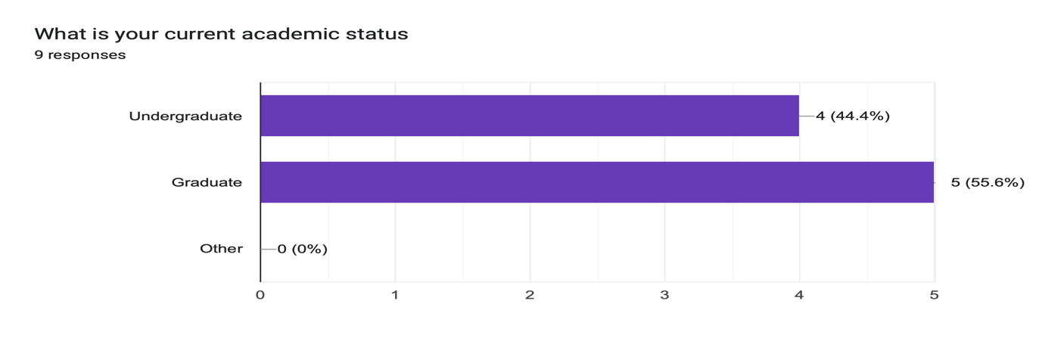

However, the survey represented student of most of identities represented at the US communities
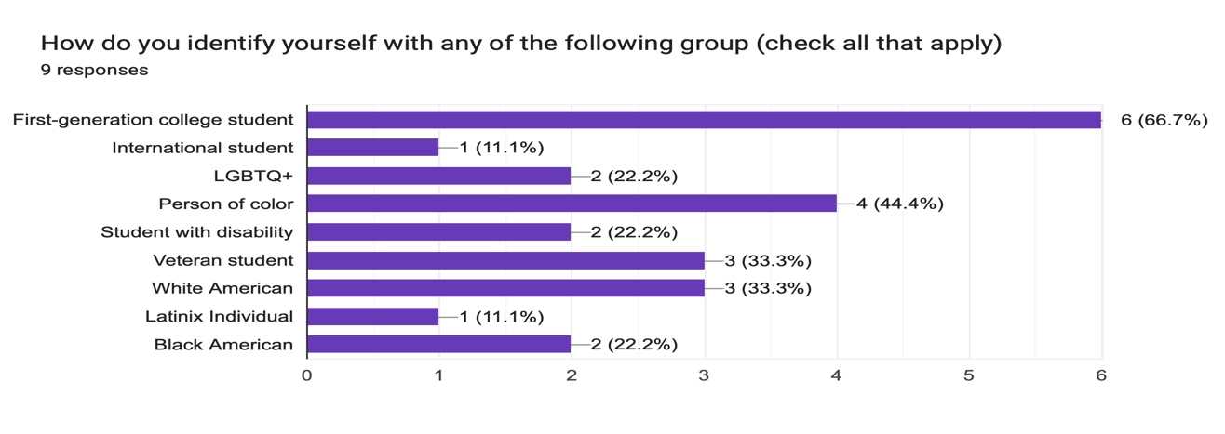
About two third of the students 66.7% were aware of the elimination of the DEI at UC Denver.
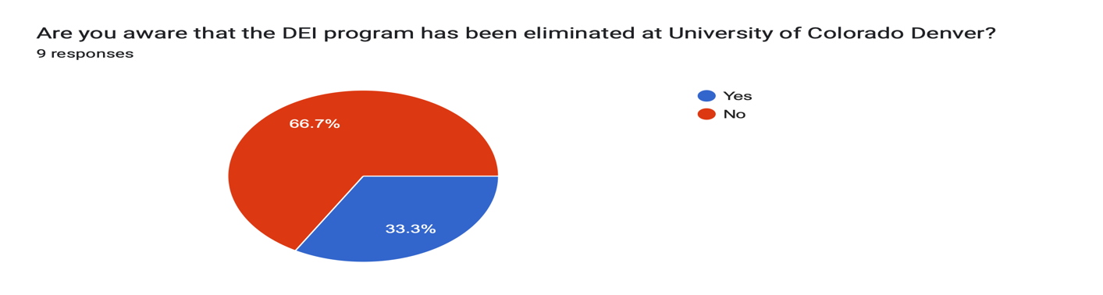
Most of the students were aware of the goal of the DEI program at UC Denver in providing support to marginalized groups and to improve campus culture 88.9% while one students 11.1% stated that the program is directed against the majority group rights.
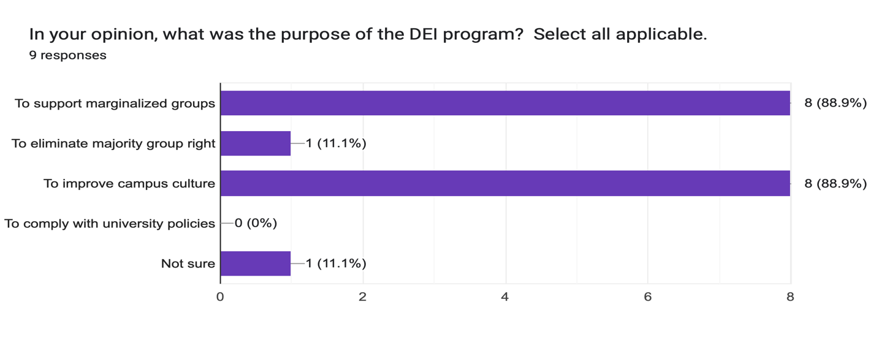
The DEI program in Denver seems to attract less people, where 77.8% of respondents stating they are not involved nor benefiting from the program. Only 22.2% benefited from the program. Those respondents were affected negatively with the government decision. The same percentage feel they lost mor opportunity for academic and personal growth. Only one respondent 11.1% expressed decreased in the belonging feeling after the removal of the DEI program.
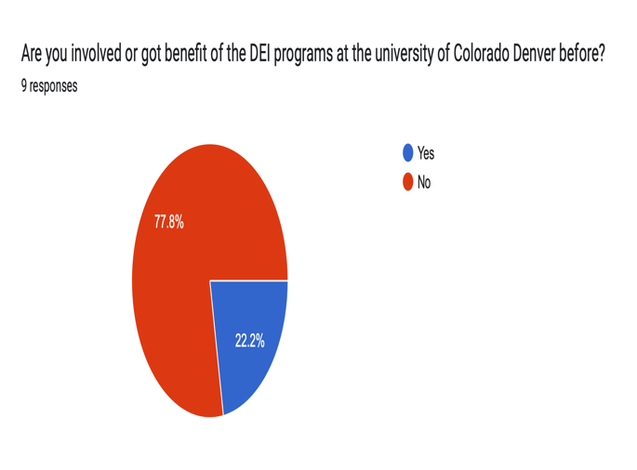 | 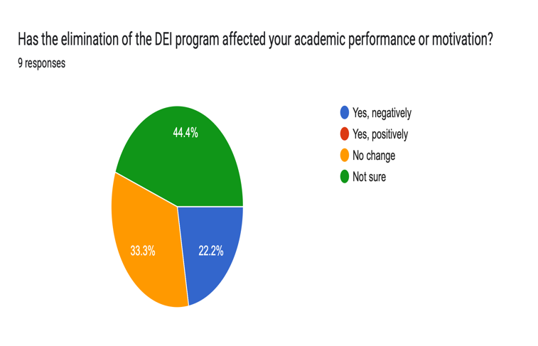
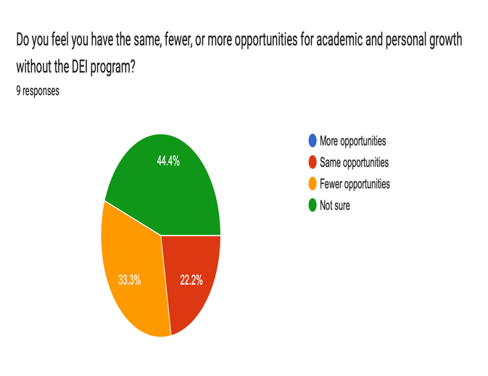 | 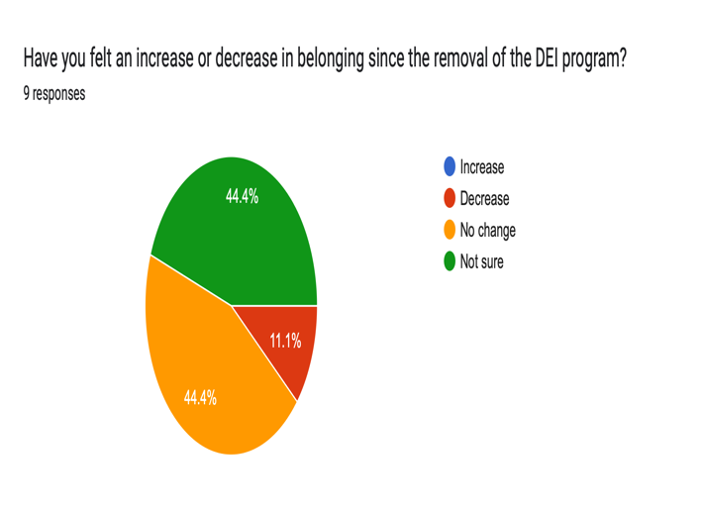

Two third of the respondents 66.7% strongly disagree with the government decision to eliminate DEI program while one respondent 11.1% strongly agree with the government decision. The same portion with neutral and somehow agree.
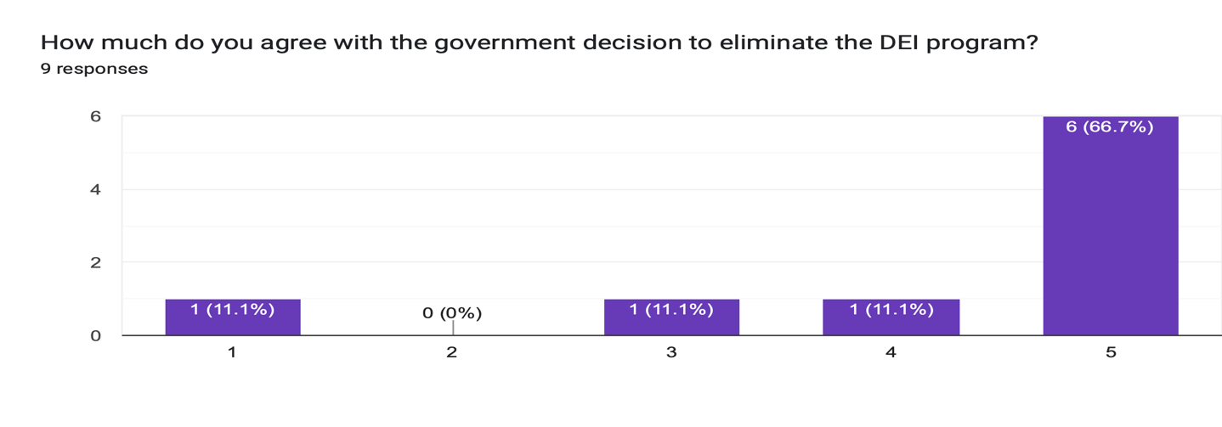
The UCD reaction of changing the name of the DEI office does not get the students support where 55.6% expressed their opposition to the CU Denver policy.
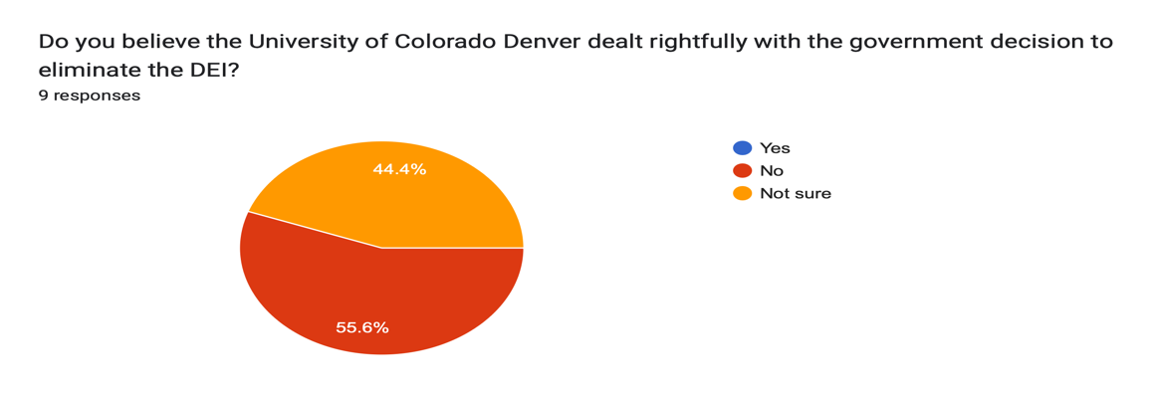

The majority of respondents 77.8% support the return of the program or an alternated version of if to the UCD
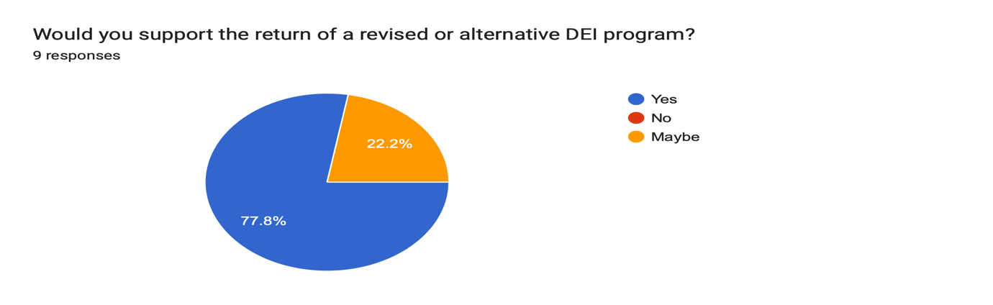
Sence of belonging at UCD and Students’ satisfaction “before” and “after” the elimination of the DEI program at the UCD stayed the same as neutral. Their identities and experiences are still respected at the UCD
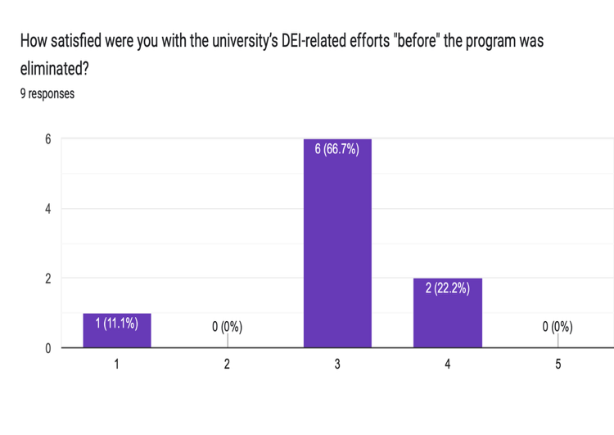 | 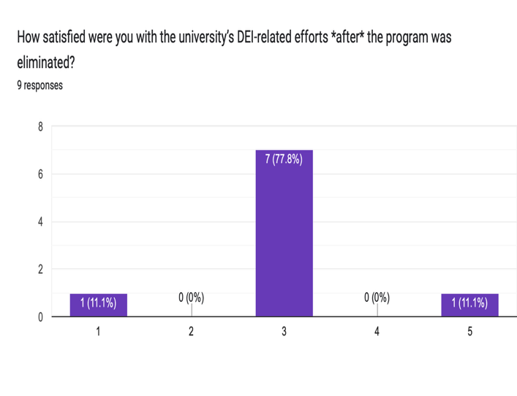
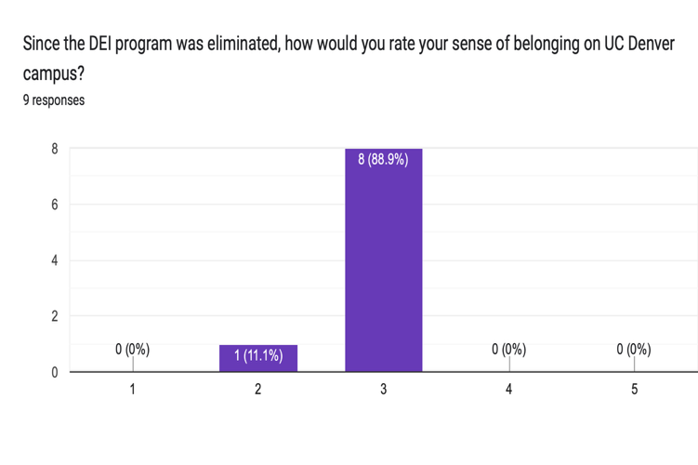 | 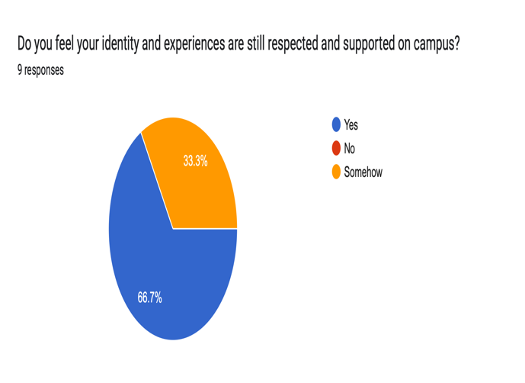

4. Discussion:
The University of Colorado Denver’s (UCD) rapid response to President Trump’s Executive Order (EO) eliminating DEI programs highlights both the organizational challenges and the communication complexities educational institutions face in a shifting political and legal landscape. UCD’s immediate rebranding of its DEI office to the “Office of Access and Campus Engagement,” along with the removal of explicit DEI language from its web presence, demonstrates a compliance-oriented approach. However, this surface-level adaptation raises important questions about institutional identity, stakeholder engagement, and the long-term effectiveness of such changes.
From an organizational communication perspective, UCD’s actions can be interpreted through Miller’s (2015) conflict framework. The university appeared to treat the EO as an “interactional conflict,” focusing on changing outward expressions (names, language) rather than addressing the deeper, underlying “incompatible goals” and “interdependence” between federal mandates and campus values. This approach may have been intended to minimize risk and ensure continued access to federal funding, but it potentially overlooks the need for transparent dialogue with students, faculty, and staff about the purpose and future of inclusion efforts on campus.
The survey data, though limited in scope, suggests that students were largely aware of the changes and recognized the historical importance of DEI, even if direct participation was limited. Notably, a majority of respondents disagreed with both the elimination of DEI and the university’s compliance measures. This disconnects between administrative action and student sentiment could have consequences for campus climate, trust in leadership, and the perceived legitimacy of institutional decision-making. In the context of organizational identity, UCD’s swift compliance may be seen as a move to protect external legitimacy (with federal authorities) at the potential expense of internal legitimacy (with students and campus stakeholders).
Furthermore, the university’s response exposes the tensions inherent in top-down policy implementation. The lack of broad consultation or transparent communication about the rationale for the changes may have contributed to student dissatisfaction and a sense of uncertainty. The continued presence of “Inclusion makes us stronger” in the office logo, despite the removal of DEI language elsewhere, illustrates the ambiguity and potential for mixed messaging that can arise when institutions attempt to navigate conflicting external and internal pressures.
Looking ahead, UCD-and similar institutions-may face ongoing conflicts with federal agencies, especially if further guidance or enforcement actions are issued. The risk of future legal or regulatory challenges underscores the importance of developing adaptive strategies that both comply with external requirements and maintain a commitment to supporting diverse student needs. This may involve reframing inclusion initiatives in ways that align with the new legal landscape while still fostering a welcoming and equitable campus environment.
5. Conclusion
The elimination of DEI programs at educational institutions, prompted by President Trump’s 2025 Executive Order and reinforced by the Department of Education’s subsequent guidance, marks a significant turning point in the history of diversity, equity, and inclusion efforts in American higher education. This policy shift, rooted in recent Supreme Court decisions and a renewed emphasis on color-blind, merit-based governance, has generated both immediate organizational changes and substantial debate within the university community.
At CU Denver, the rapid rebranding of the DEI office and removal of explicit DEI language from institutional materials reflect a broader trend of compliance and adaptation to new federal directives. However, the findings from this study suggest that these changes have not been universally embraced by students. While a majority of respondents were aware of the policy shift and recognized the historic goals of DEI programs in supporting marginalized groups, most did not personally benefit from these initiatives. Nonetheless, two-thirds of surveyed students expressed strong disagreement with the government’s decision to eliminate DEI, and more than half opposed CU Denver’s response to the executive order. The prevailing sentiment among students favors the restoration of DEI programs or the development of alternative approaches that continue to promote inclusion and support for diverse identities.
Despite these policy changes, students’ overall sense of belonging and satisfaction at CU Denver remained neutral, indicating that the removal of DEI programs has not yet led to a significant shift in campus climate. However, the limited sample size and low response rate highlight the need for more comprehensive research to fully understand the long-term effects of these developments.

References

“Dear-Colleague-Letter-Sffa-v-Harvard-109506.Pdf.” n.d. Accessed May 11, 2025. https://www.ed.gov/media/document/dear-colleague-letter-sffa-v-harvard-109506.pdf.
Education, U.S. Department of Education. n.d. “The Elementary and Secondary Education Act (ESEA) | U.S. Department of Education.” Accessed May 10, 2025. http://www.ed.gov/laws-and-policy/laws-preschool-grade-12-education/esea.
“Grutter v. Bollinger, 539 U.S. 306 (2003).” n.d. Justia Law. Accessed May 10, 2025. https://supreme.justia.com/cases/federal/us/539/306/.
Howe, Amy. 2023. “Supreme Court Strikes down Affirmative Action Programs in College Admissions.” SCOTUSblog (blog). June 29, 2023. https://www.scotusblog.com/2023/06/supreme-court-strikes-down-affirmative-action-programs-in-college-admissions/.
Justice, Department of. 2015. “Civil Rights Division | Title Ix Of The Education Amendments Of 1972.” August 6, 2015. https://www.justice.gov/crt/title-ix-education-amendments-1972.
Miller, Katherine. 2015. Organizational Communication: Approaches and Processes. 7th ed. 200 First Stamford Place, 4th Floor Stamford, CT 06902 USA: Cengage Learning.
NAACP. n.d. “History of Brown v. Board of Education.” Accessed May 10, 2025. https://naacp.org/history-brown-v-board-education.
NCRI. 2024. “INSTRUCTING ANIMOSITY: HOW DEI PEDAGOGY PRODUCES THE HOSTILE ATTRIBUTION BIAS.” Rutgers University’s Social Perception Lab. https://networkcontagion.us/wp-content/uploads/Instructing-Animosity_11.13.24.pdf.
Poff, Deborah C. 2023. “Diversity, Equity, and Inclusivity (DEI).” In Encyclopedia of Business and Professional Ethics, edited by Deborah C. Poff and Alex C. Michalos, 580–82. Cham: Springer International Publishing. https://doi.org/10.1007/978-3-030-22767-8_1295.
“Regents of Univ. of California v. Bakke, 438 U.S. 265 (1978).” n.d. Justia Law. Accessed May 10, 2025. https://supreme.justia.com/cases/federal/us/438/265/.
Tierney, William G. 1997. “The Parameters of Affirmative Action: Equity and Excellence in the Academy.” Review of Educational Research 67 (2): 165–96. https://doi.org/10.2307/1170625.
Writers, Staff. 2023. “What Is DE&I in Education?” Robert F. Smith. December 3, 2023. https://robertsmith.com/blog/what-is-dei-in-education/.

https://thedecisionlab.com/reference-guide/organizational-behavior/diversity-equity-and-inclusion-dei
https://dictionary.apa.org/diversity
https://pce.sandiego.edu/10-ways-to-teach-diversity-in-the-classroom/
https://www.nu.edu/blog/equity-in-education/
https://www.weareteachers.com/what-is-inclusion-in-education/
https://web.archive.org/web/20150518061955/http://blogs.law.harvard.edu/sharamkohan1/affirmative-action/
https://www.cnn.com/election/2024/results/president?election-data-id=2024-PG&election-painting-mode=projection-with-lead&filter-key-races=false&filter-flipped=false&filter-remaining=false
https://www.whitehouse.gov/presidential-actions/2025/01/ending-illegal-discrimination-and-restoring-merit-based-opportunity/
https://www.whitehouse.gov/presidential-actions/2025/01/ending-illegal-discrimination-and-restoring-merit-based-opportunity/
https://olucdenver.sharepoint.com/sites/CUDDiversityEquityInclusion
https://olucdenver.sharepoint.com/sites/CUDDiversityEquityInclusion

